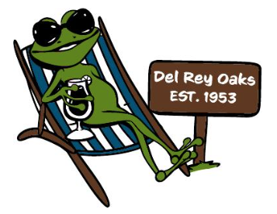

Del Rey Oaks Citizens Action group
AGENDA
Tuesday, November 14, 2023 @ 6:15 P.M.
At Old Town Hall in the park
1) CALL TO ORDER: Read Mission Statement
2) OFFICER’S REPORT
a. Treasurer’s Report: Terri Neece
b. Secretary’s Report: Claudia Campbell
c. Vice President’s Report: Julie Webb
OLD BUSINESS:
- Movie Night in the park recap: Denise Wood
NEW BUSINESS:
- Santa’s Workshop December 2, 12-2 PM
- Deliver meal to Shut ins (Vicki Lucido)

NEXT MEETING: Tuesday, January 9, 2024 @ 6:15
ADJOURNMENT
DROCAG is the longest running Community Service organization in Del Rey Oaks. We believe a good neighbor is a person who shows kindness and helpfulness toward their fellow Citizens.
We welcome any resident to join us. Meetings last between 30-60 minutes.
drocag@yahoo.com 831-915-7065 650 Canyon Del Rey Blvd, DRO, CA 93940

